Initial Report
July, 2014
1. How long have you been a member of ASR? (Please answer even if you haven't yet renewed your membership for 2014.)
# | Answer |  | Response | %
1 | Less than 1 year |  | 54 | 13%
2 | 1-2 years |  | 67 | 16%
3 | 3-4 years |  | 41 | 10%
4 | 5-9 years |  | 83 | 20%
5 | 10-14 years |  | 51 | 12%
6 | 15-20 years |  | 40 | 10%
7 | Over 20 years |  | 76 | 18%
8 | I don't consider myself a member of ASR |  | 3 | 1%
 | Total |  | 415 | 100%

Statistic | Value
Min Value | 1
Max Value | 8
Mean | 4.08
Variance | 4.19
Standard Deviation | 2.05
Total Responses | 415

2. Have you been a continuous member since then, or have there been times when you let your membership lapse?
# | Answer |  | Response | %
1 | I have been a continuous member since then. |  | 306 | 76%
2 | I have let my membership lapse once since becoming a member. |  | 71 | 18%
3 | I have let my membership lapse two or more times since becoming a member. |  | 28 | 7%
 | Total |  | 405 | 100%

3. Do you belong to any other professional associations that focus on the study of religion? If so, to which of the following do you also belong? (Select all that apply.)
# | Answer |  | Response | %
1 | No, I belong only to ASR |  | 48 | 12%
2 | Society for the Scientific Study of Religion (SSSR) |  | 286 | 69%
3 | Religious Research Association (RRA) |  | 147 | 36%
4 | American Sociological Association (ASA) Religion Section |  | 182 | 44%
5 | American Academy of Religion |  | 82 | 20%
6 | International Society for the Sociology of Religion |  | 53 | 13%
7 | Association for the Study of Religion, Economics, and Culture (ASREC) |  | 10 | 2%
8 | Others (please list): |  | 87 | 21%

Others (please list):
ISA--RC22
Network for Pastoral/Practical Theology in New Zealand
Society for Pentecostal Studies
Australian Association for the Study of Religions (AASR), Sociological Assn of Australia & New Zealand (SAANZ)
The Australian Sociolgical Associaton; The Australian Association for the Study of Religion;
Association for the Social Scientific Study of Jewry, AAPOR, Association for Jewish Studies
Asian American Religion Initiative
Australian Society for the Study of Religions
BSA sociology of religion study group, UK
Society of Biblical Literature, New York Academy of Science, Society for Research and Academic Excellence, Nigerian Association for Biblical Studies
ESA RN on Sociology of Religion
Comparative and International Education Society - Religion and Education SIG; American Educational Research Association - Religion and Education SIG
International Sociological Association, RC 22
CSA
Association for Jewish Studies
American Association for the Study of Religion
IABS, IAHR, DVRW, Arbeitskreis Objektive Hermeneutik
Association of Jewish Studies; Association for the Social Scientific Study of Jewry
Canadian Society for the Study of Relgiion
Nonreligion and Secularity Research Network
BASR
Canadian Society for Studies in Religion
NRSN, CSSR
ASEC-Assoc. for the Study of Easter Christian History and Culture
Buddhist Christian Studies
ISA, IAHR via my national association
Asian Pacific American Religious Research Initiative, Society of Asian North American Christian Studies
Religious Communication Association
Înternational Sociological Association (ISA)
Latin American Studies Association
European Association for the Study of Religion; Finnish Association for the Study of Religion
CESNUR
Association for Jewish Studies
MESA; German Association of Middle East STudies
African Association for the study of Religion
CTS, CTSA
Asociación de Cientistas Sociales de la Religión del Mercosur
Midwest Sociological Society, Wisconsin Sociological Association
Association for Jewish Studies/Society for the Social Scientific Study of Jewry
A variety of British and European societies, including the BSA Sociology of Religion Study Group and the International Society for the Sociology of Religion
Canadian Society for the Study of Religion
International Sociological Association
AIS (Italy)
International Society for the Study of New Religions, European Association for the Study of Religion
Association for the Social Scientific Study of Jewry
Pacific Sociological Association (PSA)
Society of Biblical Literature (SBL)
International Society for the Comparative Study of Civilizations
Asociación de Cientistas Sociales del Mercosur
Sixteenth Century Studies, American Society for Church History, Society for Reformation Research, Calvin Studies Society
Asociación de Cientistas Sociales de la Religión del Mercosur
AASR
Association for the Academic Study of New Religions
ASSSJ
American Society of Church History
African Association for the Study of Religions (AASR)
ISORECEA; Section Sociology of Religion within German Sociological Association
Asociación de Cientistas Sociales de la Religión del MERCOSRU www.acsrm.org
British Sociological Association Study of Religion Group; APA division 36
APSR - Section on Religion and Politics
Japanese Association for Religious Studies
British Sociological Association Religion Section (SocRel)
Church History, Catholic Historical Association
Contemporary Jewry
PAA
Cehila, Aler ICER
Faiths & Civil Society Unit
SBC RF
ESA Sociology of Religion Research Network
AFSR, LARSN
ISA Religion Section, APSA Religion Section
Religion and Politics Section APSA
Association for Asian Studies, Japanese Association for Religious Studies
Critical Religion Association
bass csircs
ESA, IIS, AISLF, AIS
IAPR; Div 36 APA
American Council for the Study of Islamic Societies (ACSIS)
Congregational Studies Partnership for

4. In comparison to the other associations that focus on the study of religion, how important is your participation in ASR... (Please leave blank if you do not know.)
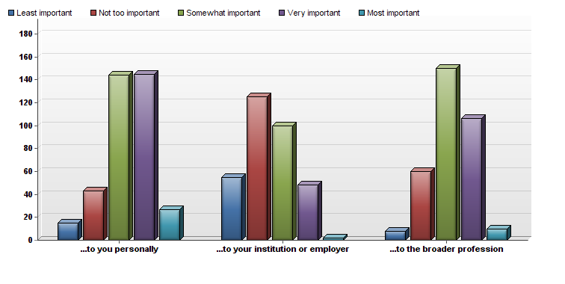
# | Question | Least important | Not too important | Somewhat important | Very important | Most important | Total Responses | Mean
1 | ...to you personally | 15 | 43 | 144 | 145 | 27 | 374 | 3.34
2 | ...to your institution or employer | 55 | 125 | 100 | 48 | 2 | 330 | 2.45
3 | ...to the broader profession | 8 | 60 | 150 | 106 | 10 | 334 | 3.15

Statistic | ...to you personally | ...to your institution or employer | ...to the broader profession
Min Value | 1 | 1 | 1
Max Value | 5 | 5 | 5
Mean | 3.34 | 2.45 | 3.15
Variance | 0.84 | 0.91 | 0.69
Standard Deviation | 0.92 | 0.95 | 0.83
Total Responses | 374 | 330 | 334

5. Here are a few questions about your participation in recent annual meetings. For each of the following, please check all that apply. If you have problems recalling whether you participated in these events in any given year, please refer to the notes below this question to jog your memory.
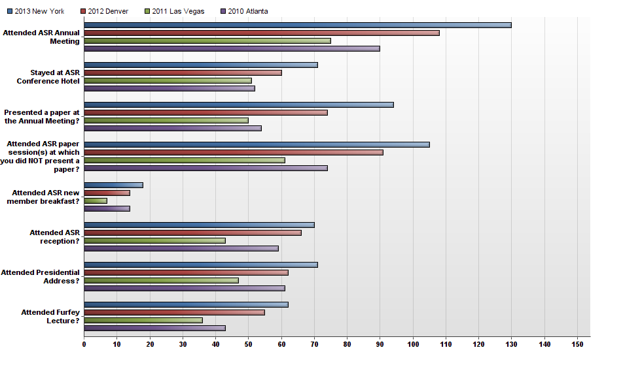
# | Question | 2013 New York | 2012 Denver | 2011 Las Vegas | 2010 Atlanta | Total Responses
1 | Attended ASR Annual Meeting | 130 | 108 | 75 | 90 | 403
2 | Stayed at ASR Conference Hotel | 71 | 60 | 51 | 52 | 234
3 | Presented a paper at the Annual Meeting? | 94 | 74 | 50 | 54 | 272
4 | Attended ASR paper session(s) at which you did NOT present a paper? | 105 | 91 | 61 | 74 | 331
5 | Attended ASR new member breakfast? | 18 | 14 | 7 | 14 | 53
6 | Attended ASR reception? | 70 | 66 | 43 | 59 | 238
7 | Attended Presidential Address? | 71 | 62 | 47 | 61 | 241
8 | Attended Furfey Lecture? | 62 | 55 | 36 | 43 | 196

6. Examining your responses to the above questions, if you do NOT typically attend the Annual Meetings or if there are any aspects of the Annual Meetings that you do NOT typically participate in, could you briefly explain why? (Your responses will help us with planning.)
Text Response
Common Responses included:

- Lack of travel funds
- Distance to city where conference is being held
- Difficult to travel in August
- Distance between ASA hotels and ASR hotel
- Can only attend one conference and prefer SSSR/RRA.

Statistic | Value
Total Responses | 231

7. Overall, how satisfied are you with the current direction of the ASR?
# | Answer |  | Response | %
1 | Very Satisfied |  | 129 | 34%
2 | Somewhat satisfied |  | 109 | 28%
3 | Neutral |  | 127 | 33%
4 | Somewhat dissatisfied |  | 18 | 5%
5 | Very dissatisfied |  | 0 | 0%
 | Total |  | 383 | 100%

Statistic | Value
Min Value | 1
Max Value | 4
Mean | 2.09
Variance | 0.85
Standard Deviation | 0.92
Total Responses | 383

8. How satisfied have you been with the slate of candidates for Officers and Executive Council in the past few years?
# | Answer |  | Response | %
1 | Very Satisfied |  | 128 | 35%
2 | Somewhat satisfied |  | 86 | 24%
3 | Neutral |  | 141 | 39%
4 | Somewhat dissatisfied |  | 6 | 2%
5 | Very dissatisfied |  | 2 | 1%
 | Total |  | 363 | 100%

Statistic | Value
Min Value | 1
Max Value | 5
Mean | 2.09
Variance | 0.85
Standard Deviation | 0.92
Total Responses | 363

9. How satisfied are you with the current website at www.sociologyofreligion.com?
# | Answer |  | Response | %
1 | Very Satisfied |  | 146 | 39%
2 | Somewhat satisfied |  | 122 | 32%
3 | Neutral |  | 98 | 26%
4 | Somewhat dissatisfied |  | 11 | 3%
5 | Very dissatisfied |  | 2 | 1%
 | Total |  | 379 | 100%

Statistic | Value
Min Value | 1
Max Value | 5
Mean | 1.95
Variance | 0.81
Standard Deviation | 0.90
Total Responses | 379

10. How satisfied are you with ASR’s newsletter News & Announcements, which appears on the website and in the back of each issue of the journal?
# | Answer |  | Response | %
1 | Very Satisfied |  | 120 | 31%
2 | Somewhat satisfied |  | 143 | 37%
3 | Neutral |  | 107 | 28%
4 | Somewhat dissatisfied |  | 11 | 3%
5 | Very dissatisfied |  | 3 | 1%
 | Total |  | 384 | 100%

Statistic | Value
Min Value | 1
Max Value | 5
Mean | 2.05
Variance | 0.78
Standard Deviation | 0.88
Total Responses | 384

11. In 2013, over a third of ASR’s expenses went to our Annual Meeting, approximately a quarter went to the production and mailing of the journal, and another quarter went to paying for members’ grants and awards. If it were possible in the future for ASR to adjust the proportion of resources we allocate to these endeavors, what would be your preferences? Indicate the level of allocation you would prefer next to each of the following ways that ASR fulfills its mission.
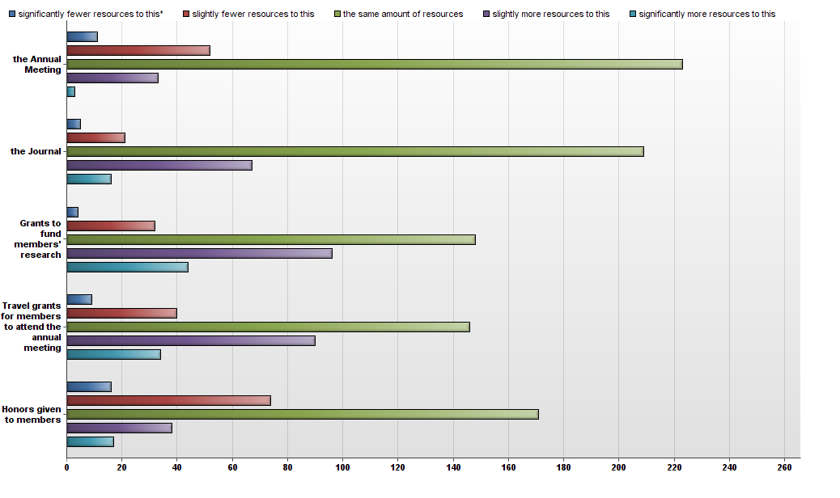
# | Question | significantly fewer resources to this* | slightly fewer resources to this | the same amount of resources | slightly more resources to this | significantly more resources to this | Total Responses | Mean
1 | the Annual Meeting | 11 | 52 | 223 | 33 | 3 | 322 | 2.89
2 | the Journal | 5 | 21 | 209 | 67 | 16 | 318 | 3.21
3 | Grants to fund members' research | 4 | 32 | 148 | 96 | 44 | 324 | 3.44
4 | Travel grants for members to attend the annual meeting | 9 | 40 | 146 | 90 | 34 | 319 | 3.31
5 | Honors given to members | 16 | 74 | 171 | 38 | 17 | 316 | 2.89

12. Please share any comments you have about how ASR is being managed. Do you have any suggestions for how the affairs of the Association could be handled better by its Officers or Council?
Text Response
Common Responses included:

- Overall happiness with current direction of ASR
- Frustration with some of the glitches with new website (e.g., problems submitting payment or submitting abstract), but overall satisfaction with website
- Glad to see new honors and awards being given

13. Annual Meetings If you attended any of the Annual Meetings in the past few years, please answer the following questions. If not, please skip to the next set of questions. Please tell us how satisfied you have been with the following aspects of the Annual Meetings in the past few years.
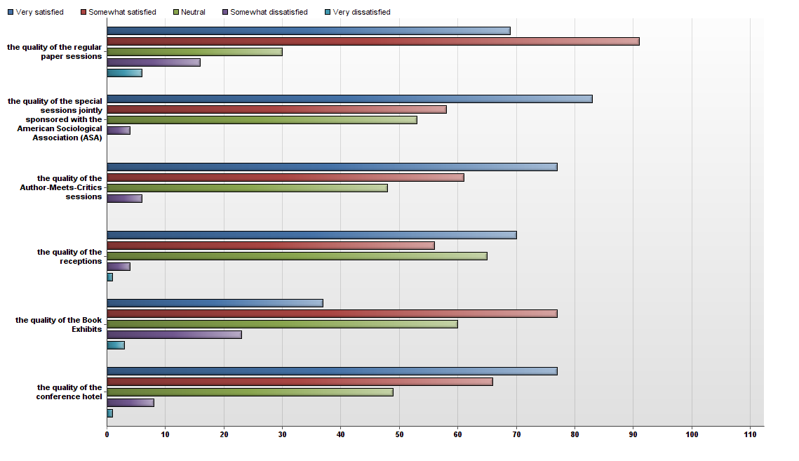
# | Question | Very satisfied | Somewhat satisfied | Neutral | Somewhat dissatisfied | Very dissatisfied | Total Responses | Mean
1 | the quality of the regular paper sessions | 69 | 91 | 30 | 16 | 6 | 212 | 2.05
2 | the quality of the special sessions jointly sponsored with the American Sociological Association (ASA) | 83 | 58 | 53 | 4 | 0 | 198 | 1.89
3 | the quality of the Author-Meets-Critics sessions | 77 | 61 | 48 | 6 | 0 | 192 | 1.91
4 | the quality of the receptions | 70 | 56 | 65 | 4 | 1 | 196 | 2.03
5 | the quality of the Book Exhibits | 37 | 77 | 60 | 23 | 3 | 200 | 2.39
6 | the quality of the conference hotel | 77 | 66 | 49 | 8 | 1 | 201 | 1.96

Statistic | the quality of the regular paper sessions | the quality of the special sessions jointly sponsored with the American Sociological Association (ASA) | the quality of the Author-Meets-Critics sessions | the quality of the receptions | the quality of the Book Exhibits | the quality of the conference hotel
Min Value | 1 | 1 | 1 | 1 | 1 | 1
Max Value | 5 | 4 | 4 | 5 | 5 | 5
Mean | 2.05 | 1.89 | 1.91 | 2.03 | 2.39 | 1.96
Variance | 1.03 | 0.76 | 0.77 | 0.82 | 0.93 | 0.83
Standard Deviation | 1.01 | 0.87 | 0.88 | 0.91 | 0.97 | 0.91
Total Responses | 212 | 198 | 192 | 196 | 200 | 201

14. In the future, how important is it to you that ASR…
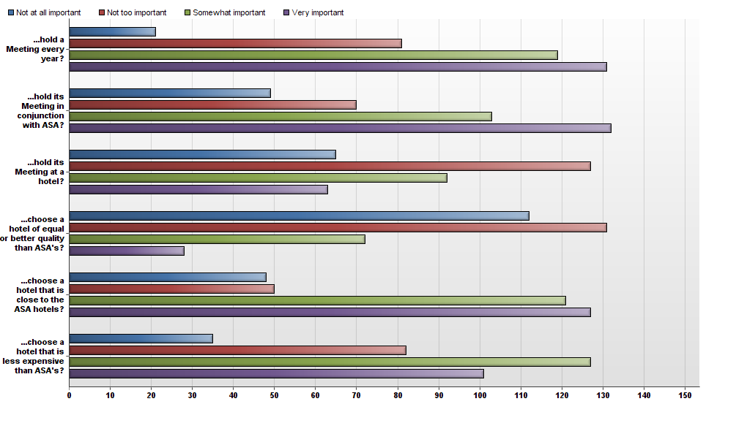
# | Question | Not at all important | Not too important | Somewhat important | Very important | Total Responses | Mean
1 | ...hold a Meeting every year? | 21 | 81 | 119 | 131 | 352 | 3.02
2 | ...hold its Meeting in conjunction with ASA? | 49 | 70 | 103 | 132 | 354 | 2.90
3 | ...hold its Meeting at a hotel? | 65 | 127 | 92 | 63 | 347 | 2.44
4 | ...choose a hotel of equal or better quality than ASA's? | 112 | 131 | 72 | 28 | 343 | 2.05
5 | ...choose a hotel that is close to the ASA hotels? | 48 | 50 | 121 | 127 | 346 | 2.95
6 | ...choose a hotel that is less expensive than ASA's? | 35 | 82 | 127 | 101 | 345 | 2.85

Statistic | ...hold a Meeting every year? | ...hold its Meeting in conjunction with ASA? | ...hold its Meeting at a hotel? | ...choose a hotel of equal or better quality than ASA's? | ...choose a hotel that is close to the ASA hotels? | ...choose a hotel that is less expensive than ASA's?
Min Value | 1 | 1 | 1 | 1 | 1 | 1
Max Value | 4 | 4 | 4 | 4 | 4 | 4
Mean | 3.02 | 2.90 | 2.44 | 2.05 | 2.95 | 2.85
Variance | 0.84 | 1.12 | 0.99 | 0.86 | 1.07 | 0.92
Standard Deviation | 0.92 | 1.06 | 0.99 | 0.93 | 1.03 | 0.96
Total Responses | 352 | 354 | 347 | 343 | 346 | 345

15. How important is it to you that each of the following components be included or available at future Meetings?
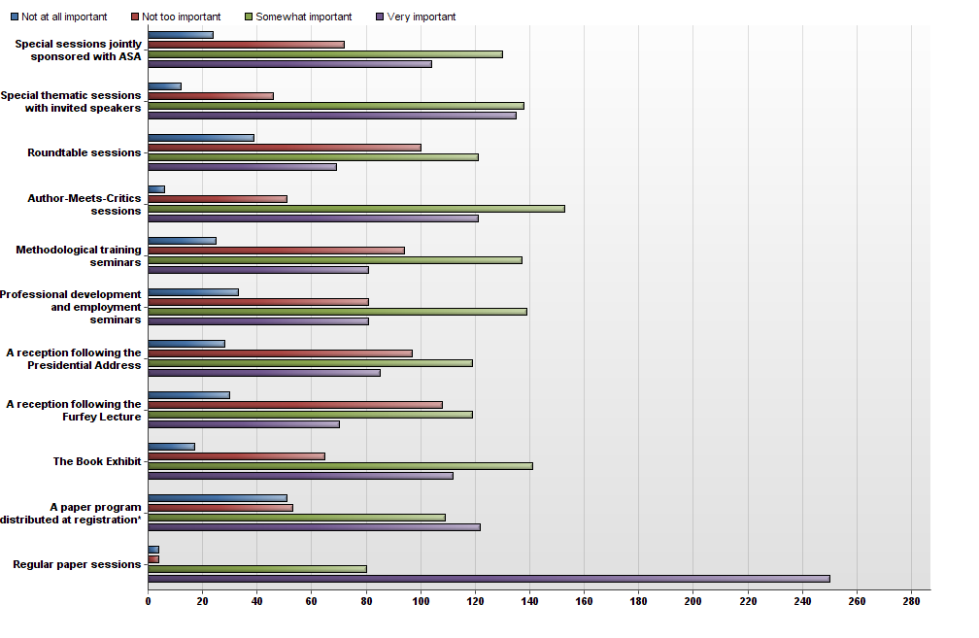
# | Question | Not at all important | Not too important | Somewhat important | Very important | Total Responses | Mean
1 | Special sessions jointly sponsored with ASA | 24 | 72 | 130 | 104 | 330 | 2.95
2 | Special thematic sessions with invited speakers | 12 | 46 | 138 | 135 | 331 | 3.20
3 | Roundtable sessions | 39 | 100 | 121 | 69 | 329 | 2.67
4 | Author-Meets-Critics sessions | 6 | 51 | 153 | 121 | 331 | 3.18
5 | Methodological training seminars | 25 | 94 | 137 | 81 | 337 | 2.81
6 | Professional development and employment seminars | 33 | 81 | 139 | 81 | 334 | 2.80
7 | A reception following the Presidential Address | 28 | 97 | 119 | 85 | 329 | 2.79
8 | A reception following the Furfey Lecture | 30 | 108 | 119 | 70 | 327 | 2.70
9 | The Book Exhibit | 17 | 65 | 141 | 112 | 335 | 3.04
10 | A paper program distributed at registration* | 51 | 53 | 109 | 122 | 335 | 2.90
11 | Regular paper sessions | 4 | 4 | 80 | 250 | 338 | 3.70

Statistic | Special sessions jointly sponsored with ASA | Special thematic sessions with invited speakers | Roundtable sessions | Author-Meets-Critics sessions | Methodological training seminars | Professional development and employment seminars | A reception following the Presidential Address | A reception following the Furfey Lecture | The Book Exhibit | A paper program distributed at registration* | Regular paper sessions
Min Value | 1 | 1 | 1 | 1 | 1 | 1 | 1 | 1 | 1 | 1 | 1
Max Value | 4 | 4 | 4 | 4 | 4 | 4 | 4 | 4 | 4 | 4 | 4
Mean | 2.95 | 3.20 | 2.67 | 3.18 | 2.81 | 2.80 | 2.79 | 2.70 | 3.04 | 2.90 | 3.70
Variance | 0.82 | 0.66 | 0.88 | 0.56 | 0.78 | 0.84 | 0.85 | 0.82 | 0.73 | 1.12 | 0.30
Standard Deviation | 0.91 | 0.81 | 0.94 | 0.75 | 0.89 | 0.92 | 0.92 | 0.91 | 0.86 | 1.06 | 0.55
Total Responses | 330 | 331 | 329 | 331 | 337 | 334 | 329 | 327 | 335 | 335 | 338

16. A few years ago, ASR started scheduling its Annual Meetings to take place during the two days immediately prior to the day of ASA’s Religion Section sessions, but not to overlap with those sessions. This allows members to attend sessions at both meetings in a shorter window than previously, but it also means that ASR’s Annual Meetings sometimes overlap with ASA (e.g., when ASA schedules the Religion Section Day toward the end of the ASA).If this current way of scheduling is NOT to your liking, please indicate your preferred alternative(s) by responding to the following statements.
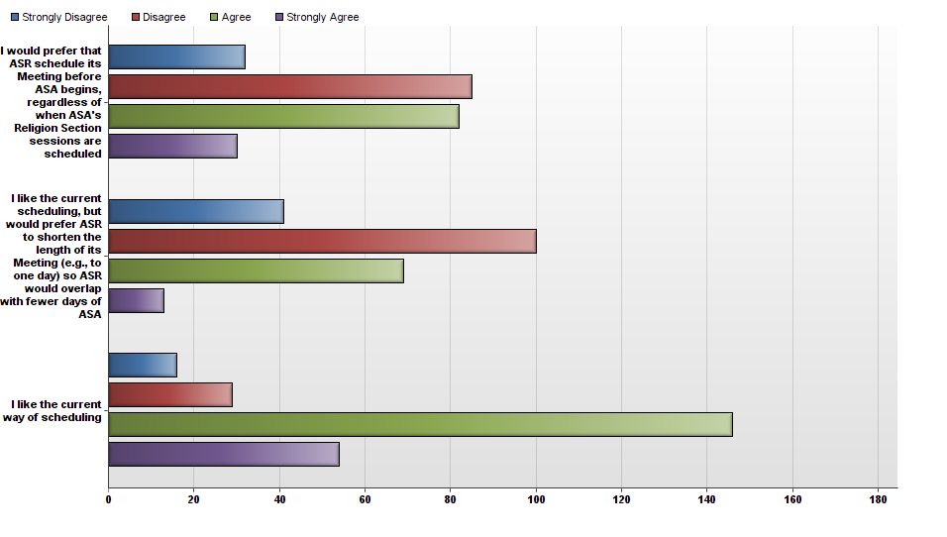
# | Question | Strongly Disagree | Disagree | Agree | Strongly Agree | Total Responses | Mean
1 | I would prefer that ASR schedule its Meeting before ASA begins, regardless of when ASA's Religion Section sessions are scheduled | 32 | 85 | 82 | 30 | 229 | 2.48
2 | I like the current scheduling, but would prefer ASR to shorten the length of its Meeting (e.g., to one day) so ASR would overlap with fewer days of ASA | 41 | 100 | 69 | 13 | 223 | 2.24
3 | I like the current way of scheduling | 16 | 29 | 146 | 54 | 245 | 2.97

Statistic | I would prefer that ASR schedule its Meeting before ASA begins, regardless of when ASA's Religion Section sessions are scheduled | I like the current scheduling, but would prefer ASR to shorten the length of its Meeting (e.g., to one day) so ASR would overlap with fewer days of ASA | I like the current way of scheduling
Min Value | 1 | 1 | 1
Max Value | 4 | 4 | 4
Mean | 2.48 | 2.24 | 2.97
Variance | 0.79 | 0.67 | 0.60
Standard Deviation | 0.89 | 0.82 | 0.78
Total Responses | 229 | 223 | 245

17. Please share any comments you have about the Annual Meetings. Do you have any suggestions for how the meetings could be improved (e.g., changing the timing, duration, frequency, or location of the meetings, meeting in conjunction with a different professional association, developing sessions around particular themes, etc.)?
Text Response
Common Responses included:

- Consider having meetings in a venue other than a hotel
- Many like the fact that ASR is scheduled in conjunction with ASA, but some wish that ASR was not linked to ASA
- Consider having meeting in less expensive cities
- Some of the papers in recent years have seemed lackluster
- ASR should offer something more distinctive so it doesn’t seem to be offering more of the same of what the Religion Section of ASA offers

Statistic | Value
Total Responses | 65

18. Publications ASR’s journal Sociology of Religion (SoR) aims to advance scholarship in the sociological study of religion by publishing original work without regard to substantive focus, theoretical orientation, or methodological approach. With this in mind, please tell us how satisfied you are with the following items related to Sociology of Religion.
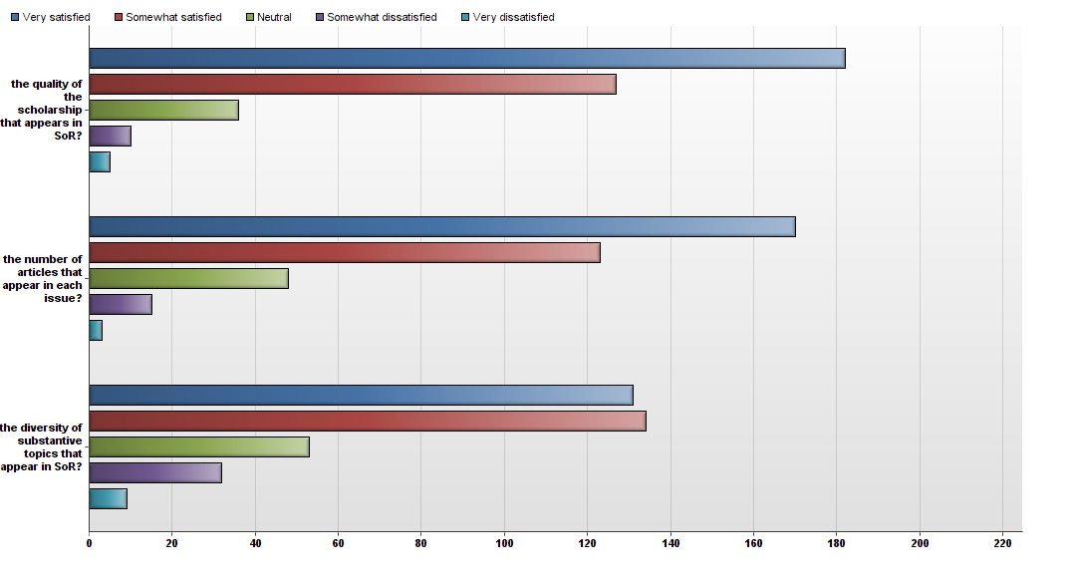
# | Question | Very satisfied | Somewhat satisfied | Neutral | Somewhat dissatisfied | Very dissatisfied | Total Responses | Mean
1 | the quality of the scholarship that appears in SoR? | 182 | 127 | 36 | 10 | 5 | 360 | 1.69
2 | the number of articles that appear in each issue? | 170 | 123 | 48 | 15 | 3 | 359 | 1.77
3 | the diversity of substantive topics that appear in SoR? | 131 | 134 | 53 | 32 | 9 | 359 | 2.04

Statistic | the quality of the scholarship that appears in SoR? | the number of articles that appear in each issue? | the diversity of substantive topics that appear in SoR?
Min Value | 1 | 1 | 1
Max Value | 5 | 5 | 5
Mean | 1.69 | 1.77 | 2.04
Variance | 0.75 | 0.80 | 1.10
Standard Deviation | 0.87 | 0.89 | 1.05
Total Responses | 360 | 359 | 359

19. How satisfied are you with ASR’s book series, Religion and the Social Order?
# | Answer |  | Response | %
1 | Very Satisfied |  | 43 | 14%
2 | Somewhat satisfied |  | 72 | 24%
3 | Neutral |  | 162 | 54%
4 | Somewhat dissatisfied |  | 16 | 5%
5 | Very dissatisfied |  | 8 | 3%
 | Total |  | 301 | 100%

Statistic | Value
Min Value | 1
Max Value | 5
Mean | 2.58
Variance | 0.80
Standard Deviation | 0.89
Total Responses | 301

20. Please share any comments you have about the journal Sociology of Religion or about the Religion and the Social Order book series. Do you have any suggestions for how ASR’s publications could be improved?
Text Response
Common Responses included:

- Expand diversity of perspectives in journal. More international focus.
- Publish more articles per issue.
- Brill’s books are too expensive, making them less accessible, impractical for course readings, and less influential in the discipline.
- Desire to know more about the book series. Who decides on the editors and contributors? How does someone submit a proposal for a book in the series? Who evaluates the book proposals? It seems to be the same group of authors, giving it a “clubby” feel. Why can’t the series include monographs? What are the peer review criteria for the series?
- Unlike the journal, the book series does not seem to add to the prestige of ASR in any way.

Statistic | Value
Total Responses | 64

21. Grants and Awards Please tell us how satisfied you are with the following grants and awards. Again, if you don’t know how to respond, simply leave it blank.
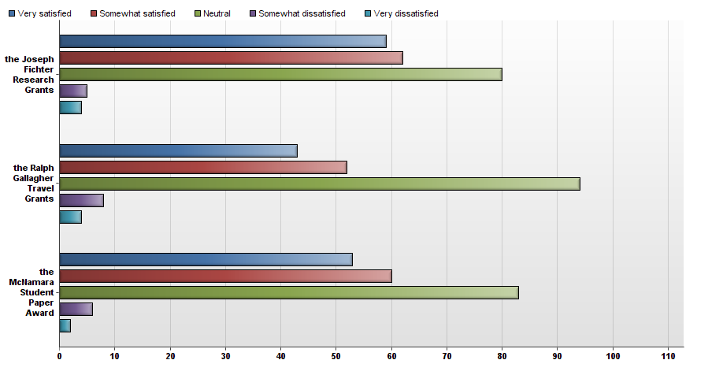
# | Question | Very satisfied | Somewhat satisfied | Neutral | Somewhat dissatisfied | Very dissatisfied | Total Responses | Mean
1 | the Joseph Fichter Research Grants | 59 | 62 | 80 | 5 | 4 | 210 | 2.20
2 | the Ralph Gallagher Travel Grants | 43 | 52 | 94 | 8 | 4 | 201 | 2.39
3 | the McNamara Student Paper Award | 53 | 60 | 83 | 6 | 2 | 204 | 2.24

Statistic | the Joseph Fichter Research Grants | the Ralph Gallagher Travel Grants | the McNamara Student Paper Award
Min Value | 1 | 1 | 1
Max Value | 5 | 5 | 5
Mean | 2.20 | 2.39 | 2.24
Variance | 0.89 | 0.87 | 0.82
Standard Deviation | 0.94 | 0.93 | 0.91
Total Responses | 210 | 201 | 204

22. Please share any comments you have about ASR’s grants and awards. Do you have any suggestions for how the grants and awards could be improved?
Text Response
Common Responses included:

- Fichter grants should be open topic areas, not limited in focus to religion and gender or religion and sexualities. Grants should be given to the highest quality proposals regardless of the topic area, as long as they are in sociology of religion.
- The amount of money distributed in travel grants to international scholars should be increased so the trip is affordable.
- The chairs of grant committees, or any committee that distributes money, should not serve in that position for more than a year.

Statistic | Value
Total Responses | 43

23. Following is a list of reasons that people have given as important for being a member of the ASR. Using the following scale, how important is each of the following factors in your decision to be a member of ASR?
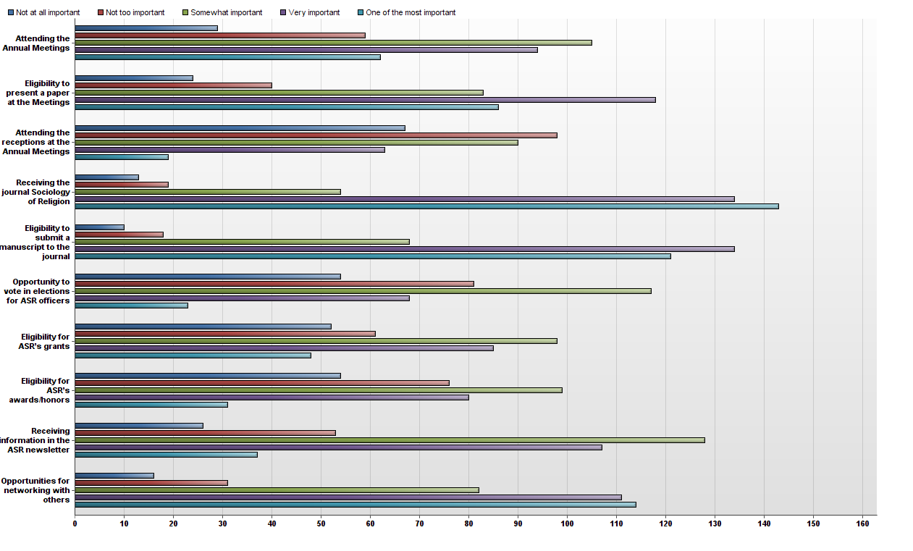
# | Question | Not at all important | Not too important | Somewhat important | Very important | One of the most important | Total Responses | Mean
1 | Attending the Annual Meetings | 29 | 59 | 105 | 94 | 62 | 349 | 3.29
2 | Eligibility to present a paper at the Meetings | 24 | 40 | 83 | 118 | 86 | 351 | 3.58
3 | Attending the receptions at the Annual Meetings | 67 | 98 | 90 | 63 | 19 | 337 | 2.61
4 | Receiving the journal Sociology of Religion | 13 | 19 | 54 | 134 | 143 | 363 | 4.03
5 | Eligibility to submit a manuscript to the journal | 10 | 18 | 68 | 134 | 121 | 351 | 3.96
6 | Opportunity to vote in elections for ASR officers | 54 | 81 | 117 | 68 | 23 | 343 | 2.78
7 | Eligibility for ASR’s grants | 52 | 61 | 98 | 85 | 48 | 344 | 3.05
8 | Eligibility for ASR’s awards/honors | 54 | 76 | 99 | 80 | 31 | 340 | 2.88
9 | Receiving information in the ASR newsletter | 26 | 53 | 128 | 107 | 37 | 351 | 3.22
10 | Opportunities for networking with others | 16 | 31 | 82 | 111 | 114 | 354 | 3.78

Statistic | Attending the Annual Meetings | Eligibility to present a paper at the Meetings | Attending the receptions at the Annual Meetings | Receiving the journal Sociology of Religion | Eligibility to submit a manuscript to the journal | Opportunity to vote in elections for ASR officers | Eligibility for ASR’s grants | Eligibility for ASR’s awards/honors | Receiving information in the ASR newsletter | Opportunities for networking with others
Min Value | 1 | 1 | 1 | 1 | 1 | 1 | 1 | 1 | 1 | 1
Max Value | 5 | 5 | 5 | 5 | 5 | 5 | 5 | 5 | 5 | 5
Mean | 3.29 | 3.58 | 2.61 | 4.03 | 3.96 | 2.78 | 3.05 | 2.88 | 3.22 | 3.78
Variance | 1.40 | 1.38 | 1.35 | 1.08 | 1.00 | 1.29 | 1.59 | 1.45 | 1.13 | 1.27
Standard Deviation | 1.18 | 1.17 | 1.16 | 1.04 | 1.00 | 1.14 | 1.26 | 1.20 | 1.06 | 1.13
Total Responses | 349 | 351 | 337 | 363 | 351 | 343 | 344 | 340 | 351 | 354

24. Following is a list of factors that make ASR distinct from other associations. Using the following scale, how important is each of the following factors in your decision to be a member of ASR?
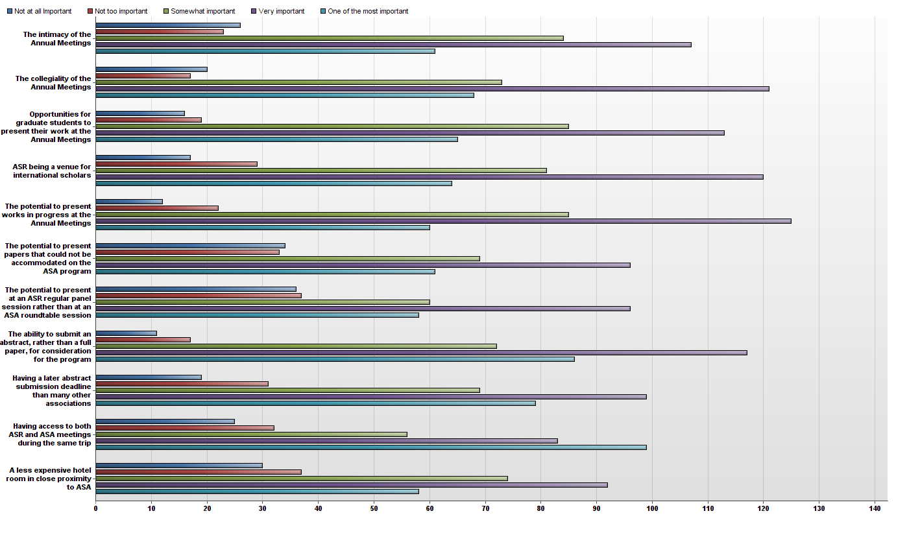
# | Question | Not at all Important | Not too important | Somewhat important | Very important | One of the most important | Total Responses | Mean
1 | The intimacy of the Annual Meetings | 26 | 23 | 84 | 107 | 61 | 301 | 3.51
2 | The collegiality of the Annual Meetings | 20 | 17 | 73 | 121 | 68 | 299 | 3.67
3 | Opportunities for graduate students to present their work at the Annual Meetings | 16 | 19 | 85 | 113 | 65 | 298 | 3.64
4 | ASR being a venue for international scholars | 17 | 29 | 81 | 120 | 64 | 311 | 3.59
5 | The potential to present works in progress at the Annual Meetings | 12 | 22 | 85 | 125 | 60 | 304 | 3.65
6 | The potential to present papers that could not be accommodated on the ASA program | 34 | 33 | 69 | 96 | 61 | 293 | 3.40
7 | The potential to present at an ASR regular panel session rather than at an ASA roundtable session | 36 | 37 | 60 | 96 | 58 | 287 | 3.36
8 | The ability to submit an abstract, rather than a full paper, for consideration for the program | 11 | 17 | 72 | 117 | 86 | 303 | 3.83
9 | Having a later abstract submission deadline than many other associations | 19 | 31 | 69 | 99 | 79 | 297 | 3.63
10 | Having access to both ASR and ASA meetings during the same trip | 25 | 32 | 56 | 83 | 99 | 295 | 3.67
11 | A less expensive hotel room in close proximity to ASA | 30 | 37 | 74 | 92 | 58 | 291 | 3.38

Statistic | The intimacy of the Annual Meetings | The collegiality of the Annual Meetings | Opportunities for graduate students to present their work at the Annual Meetings | ASR being a venue for international scholars | The potential to present works in progress at the Annual Meetings | The potential to present papers that could not be accommodated on the ASA program | The potential to present at an ASR regular panel session rather than at an ASA roundtable session | The ability to submit an abstract, rather than a full paper, for consideration for the program | Having a later abstract submission deadline than many other associations | Having access to both ASR and ASA meetings during the same trip | A less expensive hotel room in close proximity to ASA
Min Value | 1 | 1 | 1 | 1 | 1 | 1 | 1 | 1 | 1 | 1 | 1
Max Value | 5 | 5 | 5 | 5 | 5 | 5 | 5 | 5 | 5 | 5 | 5
Mean | 3.51 | 3.67 | 3.64 | 3.59 | 3.65 | 3.40 | 3.36 | 3.83 | 3.63 | 3.67 | 3.38
Variance | 1.33 | 1.20 | 1.12 | 1.17 | 1.01 | 1.58 | 1.65 | 1.05 | 1.36 | 1.62 | 1.51
Standard Deviation | 1.15 | 1.09 | 1.06 | 1.08 | 1.00 | 1.26 | 1.28 | 1.02 | 1.17 | 1.27 | 1.23
Total Responses | 301 | 299 | 298 | 311 | 304 | 293 | 287 | 303 | 297 | 295 | 291

25. Are there any OTHER factors that are important for your decision to be a member of the ASR? If so, please list them here.
Text Response
Common Responses included:

- Appreciate being a reviewer for SoR, which is rising in rankings.
- Appreciate having an opportunity to serve on committees or other leadership positions in the Association.
- Continuing the legacy of the original founders of the Association. Appreciation of the history and tradition of the Association.
- Appreciate the smaller, more intimate meetings.
- ASR allows for expression of a richer array of perspectives on the role of religion in society than is found at ASA.
- The international scope of the Association, and its efforts to include discussion of religions in non-Western countries, particularly in Asia and Africa.
- For international scholars, the opportunity to stay in touch with U.S. scholarship on religion.
- For international scholars, the dates of ASR’s meetings (i.e., in August) work better than the dates of SSSR/RRA.
- Appreciation of the affordable membership fees.

Statistic | Value
Total Responses | 42

26. At this point, how likely is it that you will choose to remain a member of the ASR for the upcoming calendar year (2015)?
# | Answer |  | Response | %
1 | Virtually certain |  | 177 | 47%
2 | Very likely |  | 130 | 35%
3 | Somewhat likely |  | 30 | 8%
4 | Not sure |  | 26 | 7%
5 | Somewhat unlikely |  | 6 | 2%
6 | Very unlikely |  | 6 | 2%
 | Total |  | 375 | 100%

Statistic | Value
Min Value | 1
Max Value | 6
Mean | 1.86
Variance | 1.21
Standard Deviation | 1.10
Total Responses | 375

27. Approximately 25% of ASR’s members are graduate students. With this in mind, how effective do you think each of the following proposals would be for increasing their participation in the Association?
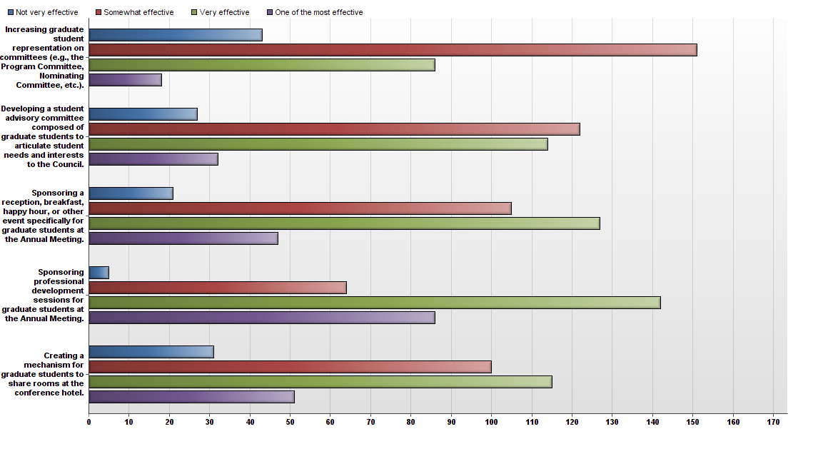
# | Question | Not very effective | Somewhat effective | Very effective | One of the most effective | Total Responses | Mean
1 | Increasing graduate student representation on committees (e.g., the Program Committee, Nominating Committee, etc.). | 43 | 151 | 86 | 18 | 298 | 2.27
2 | Developing a student advisory committee composed of graduate students to articulate student needs and interests to the Council. | 27 | 122 | 114 | 32 | 295 | 2.51
3 | Sponsoring a reception, breakfast, happy hour, or other event specifically for graduate students at the Annual Meeting. | 21 | 105 | 127 | 47 | 300 | 2.67
4 | Sponsoring professional development sessions for graduate students at the Annual Meeting. | 5 | 64 | 142 | 86 | 297 | 3.04
5 | Creating a mechanism for graduate students to share rooms at the conference hotel. | 31 | 100 | 115 | 51 | 297 | 2.63

Statistic | Increasing graduate student representation on committees (e.g., the Program Committee, Nominating Committee, etc.). | Developing a student advisory committee composed of graduate students to articulate student needs and interests to the Council. | Sponsoring a reception, breakfast, happy hour, or other event specifically for graduate students at the Annual Meeting. | Sponsoring professional development sessions for graduate students at the Annual Meeting. | Creating a mechanism for graduate students to share rooms at the conference hotel.
Min Value | 1 | 1 | 1 | 1 | 1
Max Value | 4 | 4 | 4 | 4 | 4
Mean | 2.27 | 2.51 | 2.67 | 3.04 | 2.63
Variance | 0.61 | 0.65 | 0.68 | 0.57 | 0.79
Standard Deviation | 0.78 | 0.81 | 0.82 | 0.76 | 0.89
Total Responses | 298 | 295 | 300 | 297 | 297

28. Are there any OTHER ways that ASR could increase graduate student participation and/or improve their experiences with ASR? If so, please list them here.
Text Response
Common or Noteworthy Responses included:

- More awards and grants directed to graduate students.
- Offer a small amount of funding (e.g., $200) or discount on the hotel room to any first-time graduate student presenter at the conference.
- Create an endowment that could be used for graduate student research fellowships, or earmark a portion of the Fichter grants for graduate students.
- More mentoring opportunities for graduate students with leaders in the field.
- Activities at the meeting that will bring students into non-intimidating contact with committed, senior members in the sociology of religion.
- Have an opportunity for quick introductions of graduate students at the Welcoming Reception.
- Establish topical, working research groups that both graduate students and senior faculty can join (perhaps initially in a roundtable session at the conference) in which faculty and students share research ideas in their topic area, share emails for the establishment of a distribution list of folks working in that topic area, and eventually form collaborative research teams.
- A mentoring lunch in which each table is labeled a particular topic area in the sociology of religion.
- Enhance dissemination of information to graduate students about opportunities for them to become more involved in the Association.
- Send special letters of invitation to students in the Sociology of Religion, especially at some of the larger programs like Notre Dame, Baylor, Purdue, Texas, etc., inviting them to consider organizing sessions, presenting papers, writing book reviews for the journal, etc.
- Disseminate ASR information to graduate students via social networking websites like Facebook and Twitter.

Statistic | Value
Total Responses | 42

29. What is your sex?
# | Answer |  | Response | %
1 | Female |  | 151 | 41%
2 | Male |  | 216 | 59%
3 | Transsexual or inter-sexed |  | 1 | 0%
 | Total |  | 368 | 100%

30. What year were you born?

Statistic | Value
Total Responses | 326

31. What is your professional rank?
# | Answer |  | Response | %
1 | Undergraduate student |  | 1 | 0%
2 | Graduate student |  | 66 | 18%
3 | Post-doctoral fellow |  | 9 | 2%
4 | Non-tenure track faculty (e.g., researcher, lecturer, or instructor) |  | 38 | 10%
5 | Assistant Professor |  | 43 | 12%
6 | Associate Professor |  | 59 | 16%
7 | Full Professor |  | 90 | 25%
8 | Retired of Emeritus faculty |  | 26 | 7%
9 | Other (please write in): |  | 35 | 10%
 | Total |  | 367 | 100%

Other (please write in):
Research Director
Senior Lecturer
Visiting Researcher
Independent Scholar
Honorary Professor, Director of a church-based research agency
looking for a post-doc or a position
Head of research dept at a nonprof org
Director of Research
Retired Independent Scholar
Journalist
Faculty Research Associate
Senior researcher
none of your categories fit my job description
Denominational researcher
currently unemployed
Editor
Senior Lecturer
Emeritus but actively involved in research/writing
Episcopal priest
Denominational Researcher/Planner
Independent Scholar
emeritus full professor
Retired Lecturer
Administrator
Associate Librarian
Senior Lecturer
Senior Lecturer (UK)
Adjunct Associate Professor
Researcher
Adjunct lecturer (part time)
vjsiting scholar
PhD student
parish priest
Clergy and adjunct faculty

32. With what academic discipline are you most closely affiliated?
# | Answer |  | Response | %
1 | Sociology |  | 258 | 70%
2 | Religious Studies |  | 50 | 14%
3 | Theology |  | 14 | 4%
4 | Psychology |  | 3 | 1%
5 | Political Science |  | 5 | 1%
6 | History |  | 4 | 1%
7 | Economics |  | 1 | 0%
8 | Communications |  | 3 | 1%
9 | Other (please write in): |  | 31 | 8%
 | Total |  | 369 | 100%

Other (please write in):
Theology
Biochemistry
Socialmpolicy
public health
Comparative Education
Ministry
Ethics and Social Theory
Demography
Anthropology
Anthropology
anthropology
sociology of religion
Islamic Studies
Anthropology
Women, Gender, and Sexuality Studies
anthropology
Social work
AFRICAN AMERICAN STUDIES, AFRICAN DIASPORA STUDIES, RELIGIOUS STUDIES, HISTORY
Cultural Studies
social work
Library & Information Science
computer science
Philosophy (and now beginning to publish in military history)
Health
Missiology
ethics
Anthropology
Sociology and theology

33. Please select your country of residence.
# | Answer |  | Response | %
1 | United States of America |  | 274 | 74%
2 | United Kingdom |  | 13 | 4%
3 | Canada |  | 16 | 4%
4 | Italy |  | 7 | 2%
5 | Australia |  | 4 | 1%
6 | Germany |  | 8 | 2%
7 | Israel |  | 2 | 1%
8 | France |  | 3 | 1%
9 | Japan |  | 1 | 0%
10 | Mexico |  | 1 | 0%
11 | China |  | 0 | 0%
12 | Other (please write in): |  | 41 | 11%
 | Total |  | 370 | 100%

Other (please write in):
New Zealand
Cyprus
Sweden
Nigeria
Ireland
Croatia
NL
Hong Kong
Finland
Turkey
BRAZIL
Taiwan
Malaysia
Finland
Malaysia
Ghana
Denmark
Swaziland
Nigeria
Argentina
Switzerland
Hungary
Switzerland
Poland
Philippines
Argentina
Singapore
Argentina
Denmark
Taiwan
Ghana
Norway
Philippines
Croatia
New Zealand
Ireland
New Zealand
India
Poland
Pakistan

34. In what type of institution are you primarily employed or enrolled?
# | Answer |  | Response | %
1 | 4-year institution, PhD granting |  | 218 | 61%
2 | 4-year institution, MA granting |  | 50 | 14%
3 | 4-year institution, undergraduate only |  | 37 | 10%
4 | 2-year institution or community college |  | 5 | 1%
5 | Other (please write in): |  | 50 | 14%
 | Total |  | 360 | 100%

Other (please write in):
Independent Research Institution
Research Center
Divinity School
Research only
Retired
Self employed
Graduate Theological Union
seminary
Church based research agency
Research associations
private research centre i founded myself (part-time)
nonprofit research office
magazine
retired
theological seminary
research institution
seminary
Retired
Graduate Theological Studies
Pew Research
UK Institute of Higher Eucation= university
seminary
a regular European university with PhD granting rights
Retired
academic nonprofit
Seminary
School of Theology
full university
4 - year institution, PhD
retired
Research
Seminary
Seminary
Church
Catholic Diocesan Offices
Think Tank
but retired from that--Penn State
Retired
Seminary
Seminary
Pomtifical Catholic University
Retired
trade school
adjunct at a community college, full-time with a public school (K-12) system
Graduate instiution, PhD, MA granting
c of e
Seminary
Ph.D. granting seminary

35. Thank you for taking the time to share your ideas concerning ASR. Please use the space below for any additional feedback you wish to provide.
Text Response
Common responses include:

- Having this survey was a great idea so ASR can develop a conscious path forward.
- This survey instrument is very comprehensive and very well constructed.
- The new website has been a great improvement for ASR.
- Perhaps ASR could distribute the News & Announcements by email in addition to (or instead of) at the back of the journal.
- ASR is still too centered on the U.S. – more involvement from other countries would be welcome.
- ASR will have a bright future as long as it continues to focus on what makes it distinctive.

Statistic | Value
Total Responses | 55

